**Student Grade Report**

**NOTE: No Plagiarism will be tolerated, if found any you will be awarded ZERO (0) straight away.**

**MAKE INDEPENDENT FUNCTIONS FOR INDEPENDENT FUNCTIONALITIES.**

Write a C++ project to help your friend with small software which will help the admin to perform few operations for his department which has two major subjects of Computer Science and Mathematics. Your program should be able to start with taking inputs of Roll Number, Marks for Computer Science and Marks for Mathematics. The program should ask if he wants to continue enrolling students (Assume the array has its limit of size: 5), it should keep taking input every time the user enters Y/y. Once it has taken the inputs of Roll Number and its marks for each subject (Make sure the marks entered by user must be less or equal to 100, if user enters numbers greater than 100 it should keep taking input till the user enters a valid value). The percentage and Grades should be calculated against each student (Grades criteria is given in the end of the document). Then your program should ask the user if he wants to continue to perform other advance operations or not. If the user enters N/n, the program should end after displaying Student's Roll Number and its corresponding data:

**NOTE: YOUR DATA MUST BE DISPLAYED LIKE SHOWN AT THE LAST OF THE DOCUMENT, YOU SHOULD FOLLOW THE TEMPLATES TO DISPLAY YOUR RESULTS LIKE IN THE END.**

**For Example:**

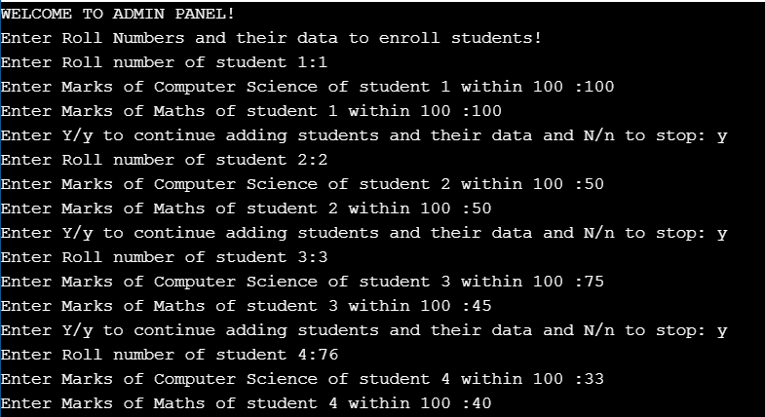

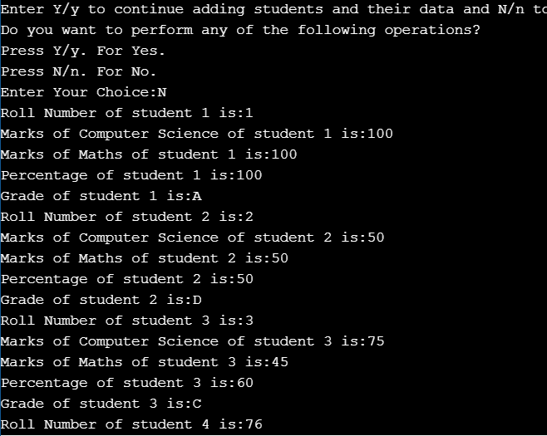



If the user says Y/y, the user should be given the advance options to choose any operation to perform from the following:

1. Press 1 to update Roll Number of a particular Student.
2. Press 2 to update marks of a particular student for CS.
3. Press 3 to update marks of CS for all students who are already enrolled.
4. Press 4 to update marks for Mathematics.
5. Press 5 to update marks of Mathematics for all students who are already enrolled.
6. Press6 to sort the data on the basis of generated percentages. The data must be sorted in ascending order. Also make sure that all the record should be sorted on the basis on percentage.
7. Press 7 to delete the record of a particular student. The example is below:

**For Example:** If user says delete the record of student with Roll Number 3. Then all the data of student will Roll Number 3 should be deleted. The data involves its Roll Number, Marks for Cs, and Marks for Mathematics, Percentage and its Grades.

**NOTE:** For operations (1, 2, 4, 6) your program should ask the user for the Roll Number of the student against which the user wants to update or delete its data for.

The program in the end should again display all of the data present in all arrays against every Roll Number and students enrolled.

**GRADE CRITERIA**

|  |  |
| --- | --- |
| **PERCENTAGE** | **GRADES** |
| <50 | F |
| >=50 && <60 | D |
| >=60 && <75 | C |
| >=75 && <=90 | B |
| >=91 && <=100 | A |

**RESULTS TEMPLATE TO FOLLOW**

